Chapter 12: Modeling with Linear Systems
Lesson 12.2: Graphing Systems of Linear Inequalities
A system of linear inequalities consists of two or more linear inequalities that have the same variables. The solutions of a system of linear inequalities are all the ordered pairs that make all the inequalities in the system true.
Example 1:
$$\left\{\begin{aligned}x+3y >3 \\ -x+y ≤6\end{aligned}\right.$$
Step 1: Find the x and y intercepts for each of the following equations.

Step 2: Graph and shape in the appropriate regions to fullfill each inequaltiey
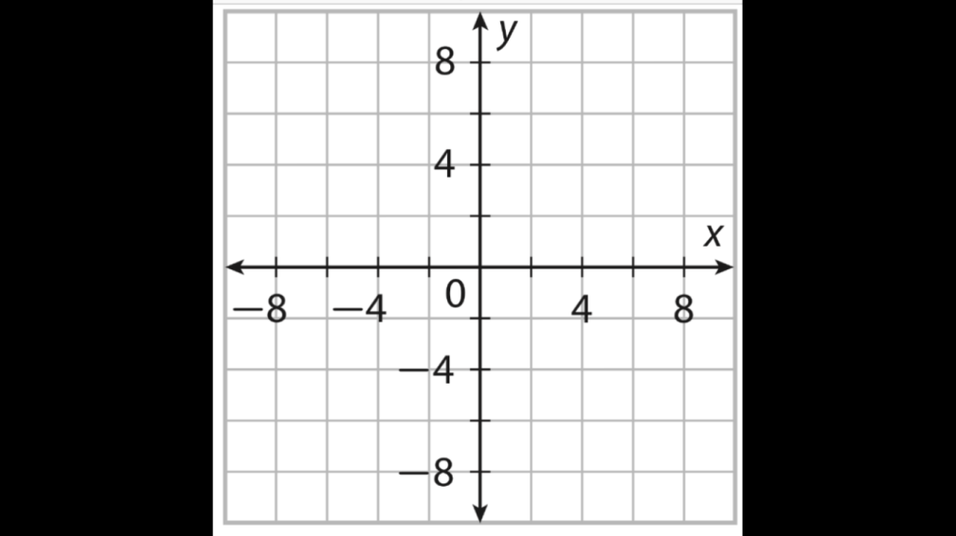

Example 2:
$$\left\{\begin{aligned}y>x-2 \\ y≤x+4\end{aligned}\right.$$
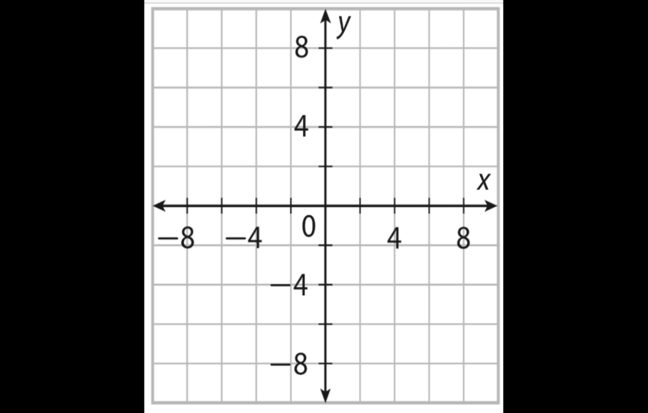

Example 3:
$$\left\{\begin{aligned}y<4x-3 \\ y>4x+2\end{aligned}\right.$$

