**Chapter 13: Piecewise-Defined Functions.**

**Lesson 13.2: Absolute Value Functions and Transformations**

The most basic Absolute function is a piecewise function given by the following rule:

$$f\left(x\right)=\left|x\right|= \left\{\begin{aligned}x , if x≥0 \\ -x , if x<0\end{aligned}\right.$$

This function is called the parent absolute value function.

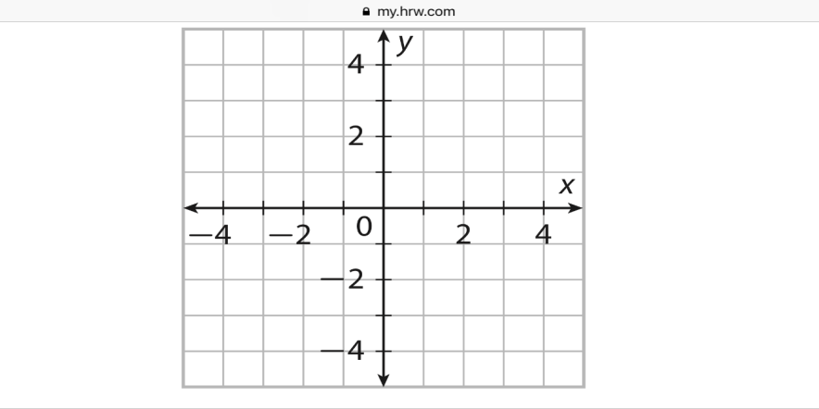 $f\left(x\right)=\left|x\right|$

|  |  |
| --- | --- |
| *x* |  |
| -3 |  |
| -2 |  |
| -1 |  |
| 0 |  |
| 1 |  |
| 2 |  |
| 3 |  |

**Example 1:**

$f\left(x\right)=\left|x+3\right|-5$

|  |  |
| --- | --- |
| *x* |  |
| -3 |  |
| -2 |  |
| -1 |  |
| 0 |  |
| 1 |  |
| 2 |  |
| 3 |  |

**Example 2:**



$f\left(x\right)=\left|x-4\right|+2$

|  |  |
| --- | --- |
| *x* |  |
| -3 |  |
| -2 |  |
| -1 |  |
| 0 |  |
| 1 |  |
| 2 |  |
| 3 |  |

**Writing Equations based off Graphs of Absolute Value Functions.**

The general form of an absolute value function is as followed:

$$f\left(x\right)= \left|x±h\right|±k$$

H is the number of units that the parent function is translated horizontally. (x-coordinate)

K is the number of units that the parent function is translated vertically. (y-coordinate)

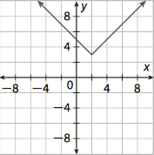**Example 1:**  **Example 2:**

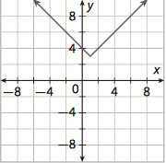

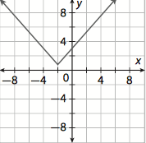**Example 3:**