Chapter 12: Modeling Linear Systems
Lesson 3: Modeling with Linear Systems
Example 1:
Bobby will buy coffee and hot chocolate for his co-workers. Each cup of coffee costs $2.25 and each cup of hot chocolate costs $1.50. If he pays a total of $15.75 for 8 cups, how many of each did he buy?

Pick a method, graphing, substitution, or elimination, to solve the following system of linear equations to find the point of intersection.

Example 2:
A student is buying pens and markers for school. Packs of pens cost $2.75 each and packs of markers cost $3.25 each. If she bought a total of 6 packs and spent $17.50, how many of each did she buy?

Pick a method, graphing, substitution, or elimination, to solve the following system of linear equations to find the point of intersection.

Example 3:
A company has to buy computers and printers. Each computer costs $550 and each printer costs $390. If the company spends $8160 and buys a total of 16 machines, how many of each did it buy?

Pick a method, graphing, substitution, or elimination, to solve the following system of linear equations to find the point of intersection.

Chapter 12: Modeling Linear Systems
Lesson 3: Modeling with Linear Systems
Example 1:
Sue is buying T-shirts and shorts. T-shirts cost $14 and shorts cost $21. She plans on spending no more than $147 and buy at least 5 items. Show and describe all combinations of the number of T-shirts and shorts she could buy?
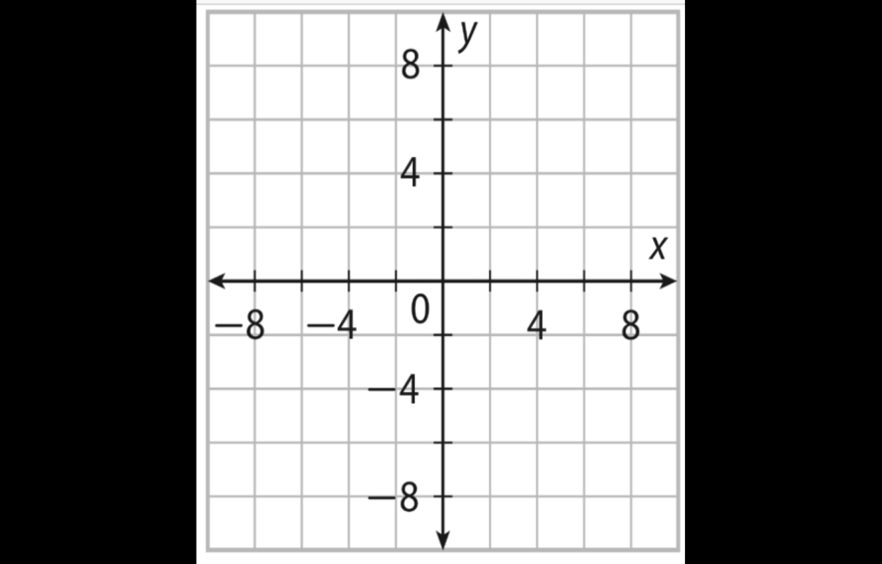

Example 2:
John has to buy two different kinds of rope. Rope A costs $0.60 per foot and Rope B costs $0.90 per foot. John needs to buy at least 15 feet of rope, but he wants to spend no more than $18. Show and describe all combinations of the number of feet of each type of rope John can buy

Example 3:
A student has to buy graph paper and printer paper. The printer paper costs $2 a pack, while the graphing paper costs $3 a pack. She wants to buy at least 6 packs of paper but wants to spend at most $27.

