Chapter 8, 9, & 10 Review Packet
Name: Date:
Directions: Answer the following questions about Frequency Tables.
1). Listed are the heights of players, in inches, on a basketball team. Create a histogram from the data.
. 79, 75, 74, 68, 63, 76, 74, 73, 69, 65, 71, 68, 74, 73, 70
Height | Frequency
63-66
67-70
71-74
75-78
79-82

2). Estimate the mean of the histogram from Number 1.

3). The net worth of the 10 richest people in the world for 2012 and 2013 (in billions) are:
2012: 69, 61, 44, 41, 37.5, 36, 30, 26, 25.5, 25.4 2013: 73, 67, 57, 53.5, 43, 34, 34, 31, 30, 29

-Create a box plot for both years.

4). Which year had the person with the highest net worth?

5). What was the difference between the highest net worth of both years?

6). Which year had the cheapest net worth?

7). What was the range of net worth’s in 2012?

8). What was the Interquartile Range of net worth’s in 2013?

The scores on a test given to all students in a school district are normally distributed with a mean of 70 and a standard deviation of 4.
9). Find the percent of students who scored between 66 and 74.

10). Find the percent of students who scored between 58 and 82

11). Estimate the Probability of a student scoring greater than 74 and indicate it on the graph below.

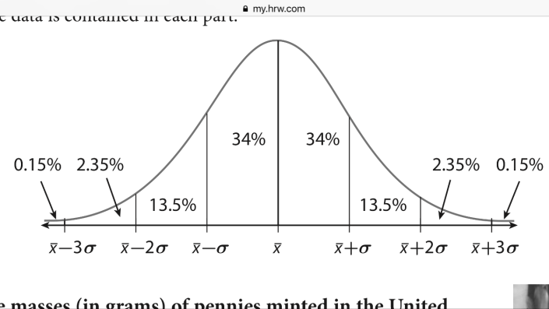

12). Estimate the Probability of a student scoring less than 62 and indicate it on the graph below.

13). Graph the following points and find a line of fit.
x | y
1 | 7
2 | 8
3 | 4
5 | 3
6 | 2
7 | 1
8 | 3
9 | 1

14). Find an equation for the line of best fit 15). find the value when x= 15.

